**Portfolio Website Analysis by Lighthouse**

The links of projects are Dummy.

**Introduction:**

It’s a Responsive Portfolio Website using HTML and CSS . Using Lighthouse I have Checked its performance and all and making it more efficient by using some more coding techniques. BlackPortfolio.html is before and Index.html is after.

**Initial Analysis**

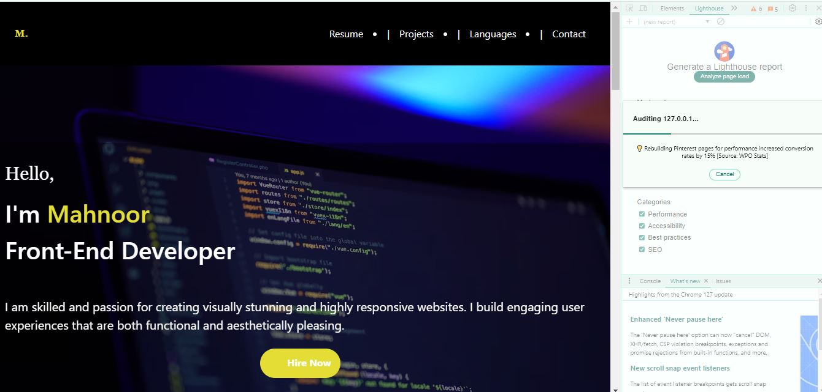

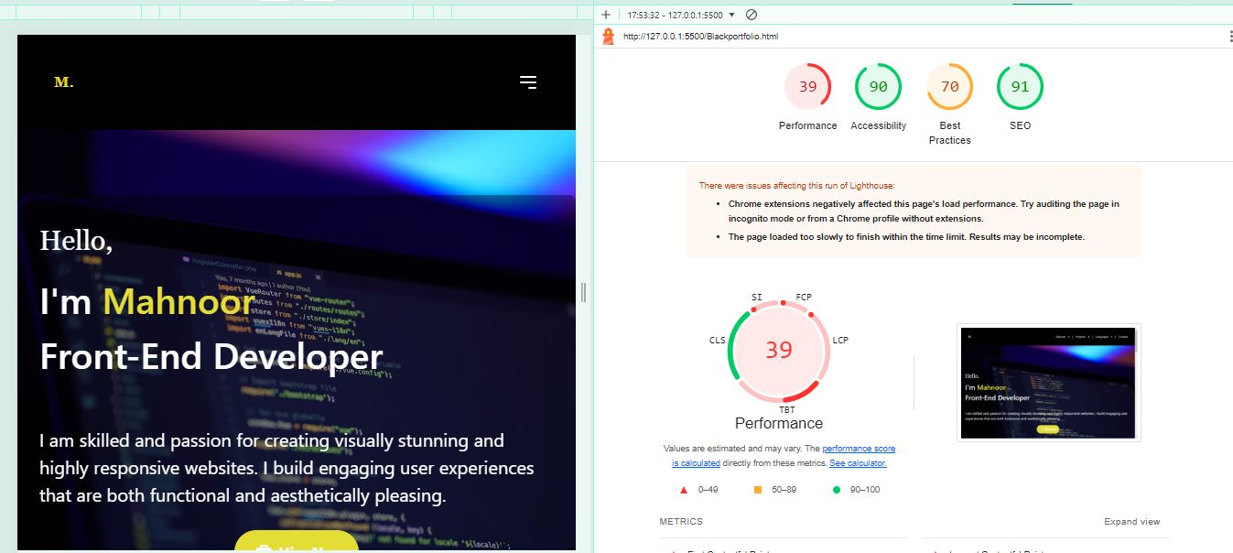

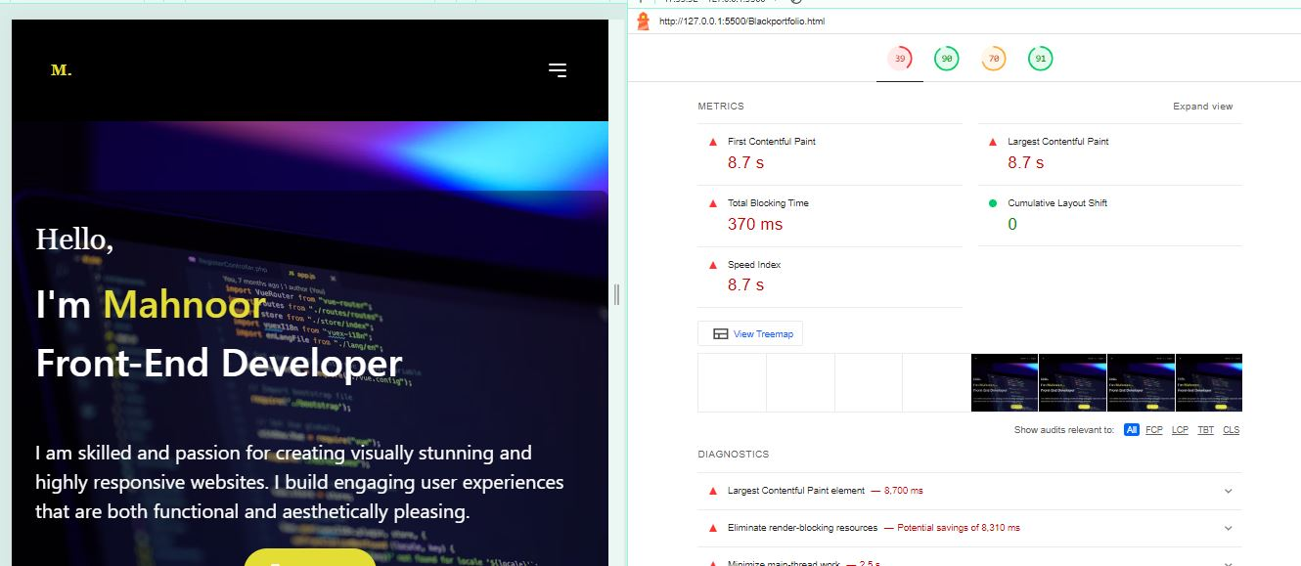

**Optimizing Steps**

• **Lazy Loading Images**: Use the loading="lazy" attribute on your images to defer loading until they are about to be displayed.

• **Defer Non-Critical JavaScript**: Use defer in your script tags to ensure that your JavaScript files load after the HTML has been parsed.

• **Optimize Animations**: Make sure animations are smooth and not blocking the main thread. Use requestAnimationFrame for any JavaScript-driven animations.

• **Minimize Main-Thread Work**: If you have heavy computations, consider moving them to web workers. However, for this example, we'll keep it simple and focus on lazy loading and deferred scripts.

**Final Analysis**

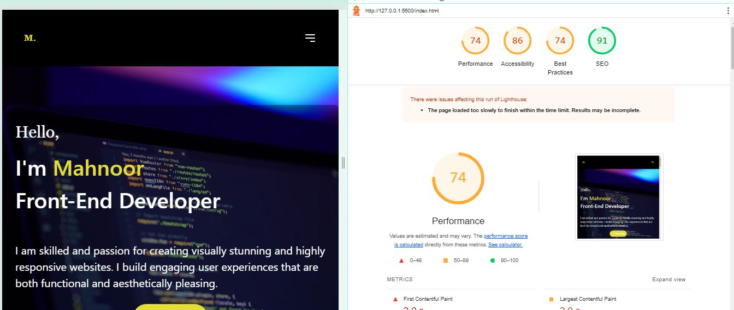

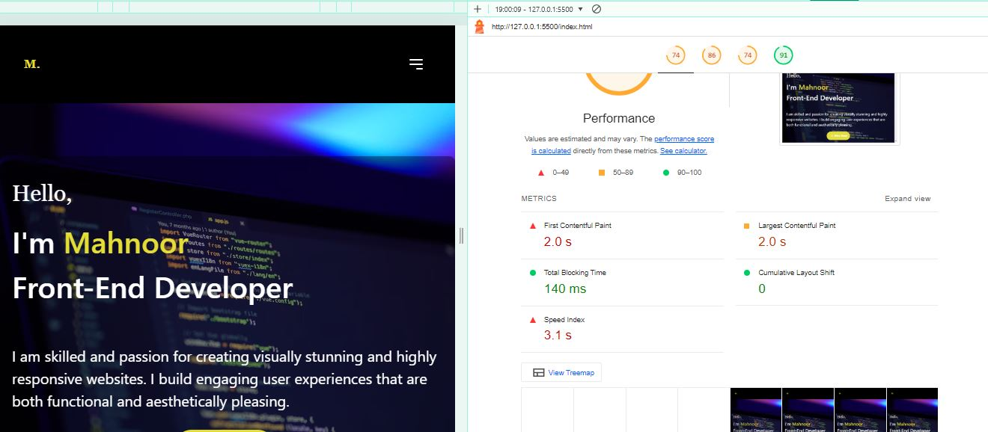

**Conclusion**

**For Better optimization these steps were taken….**

• **Lazy Loading:** Added lazy loading for images to improve initial page load time.

• **Animations:** Included animations to make the page visually appealing.

• **Responsive Design:** Ensured the design is responsive with Tailwind CSS utilities.

• **Performance Optimization:** Implemented basic performance enhancements like avoiding inline styles for better maintainability.